**♠ Beauty / Ace of Spades ♤**

*The main protagonist of our story. She is beautiful and sweet-tempered. Her hobby is reading books. She appreciates intelligence and straightforwardness in others.*

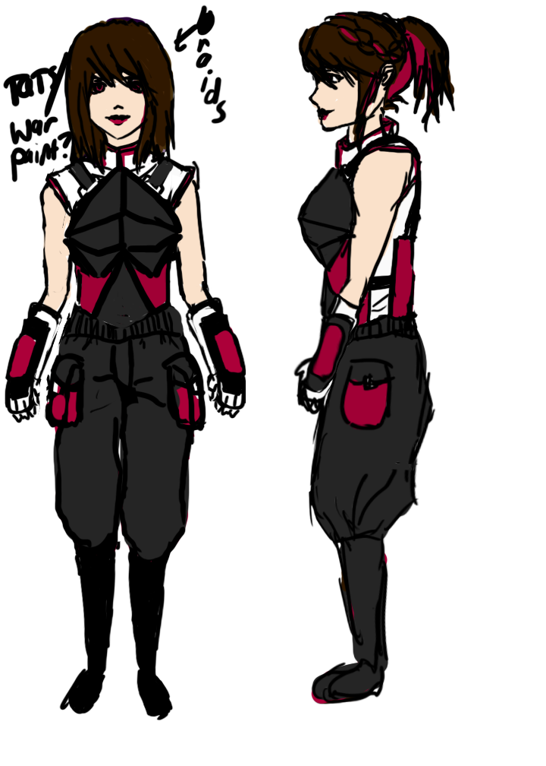

**mini-bio**

Unlike the other princesses, she comes from a humble background as a merchant’s daughter (not royalty or nobility), and has often felt snubbed or at least out of place amongst the other fairy tale protagonists.

**personality**

Loyal to family and friends, to the point of sacrificing herself for them (i.e. volunteers to go to Beast to save her father).

As Ace of Spades, she retains much of the same personality traits, but, like every other card soldier, has a fighter’s disposition and will try to evaluate people as either friend or foe when interacting with them. She has also gained some fighting abilities with knives, and is much more ruthless in her decisions. However, normally she carries a calm and nice demeanor. She has an unexplained revulsion of roses, but loves animals of all kinds. Unfortunately, the animals prefer the other princesses over her. Her tendency to do her best in her given circumstances (which defines her original personality) causes her to try to track down the other princesses with a single-mindedness that may seem unreasonable to others. When others ask her why she is working so hard to restore the original storyline, at first she will answer, “Because that is my wish,” but later on she will forget even why she wished for such a thing. For at least the beginning half of the novel, this is the side of her we will see, with glimpses of the true Beauty underneath.

**relationships**

**Beast:** She and Beast have one of the best marriage relationships amongst the royal couples. They love each other and also acknowledge each other as an equal. Their primary pastime is to debate and discuss various topics in the comforts of their living room, or go walking in the gardens that the Beast cares for. Because they are both avid readers, they have some idea of the nature of their world as a “fairy tale world,” with its own set of rules - this knowledge helps them to be one of the first to realize something is going wrong in the land.

**Cinderella**: BFF. Takes care of Cinderella.

**special points**

She owns a mirror that will allow her to see anything she wishes to see, provided that she has already seen it before.

**♥ Queen of Hearts ♥**

*Hidden primary antagonist of the story. At first, she will be shown as a caring individual who wishes to help Ace of Spades achieve her goals. Later on, Beauty will uncover that the Queen is an ambitious individual bent on turning everyone into her own personal card soldier army, thus taking over the entire world.*

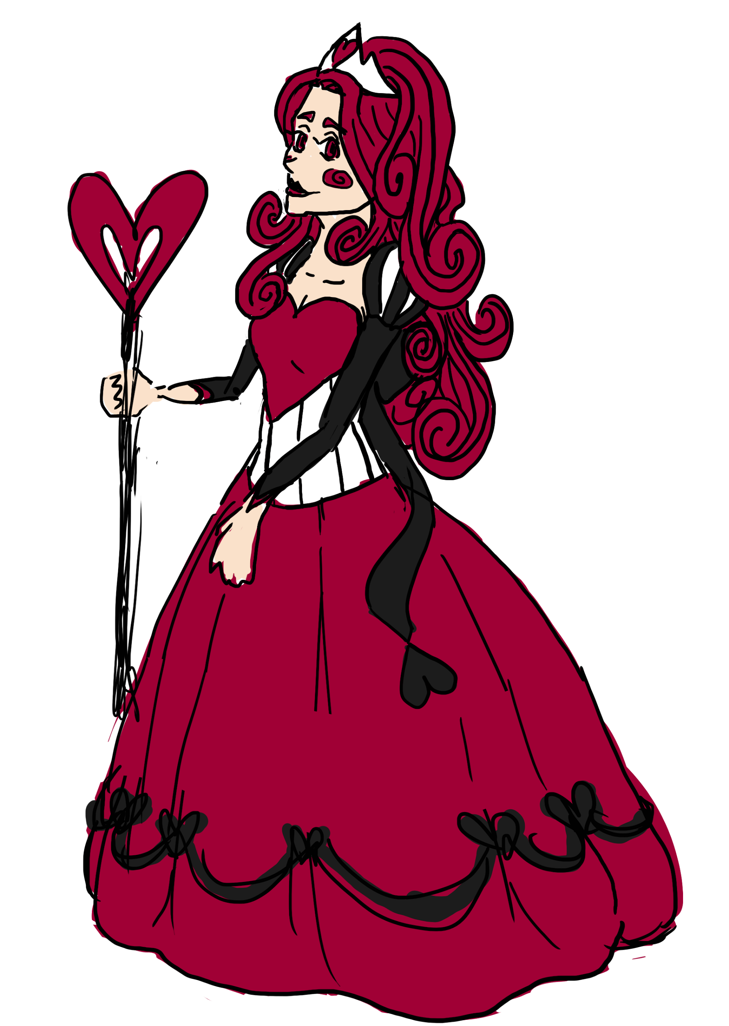

**mini bio**

Wishes to become the Queen over all the land, primarily by turning everyone else into a card soldier that is obedient to her will.

**Cheshire Cat (“Chess”)**

*Secondary protagonist and the primary info dump. He shows up during Beauty’s adventures early on and helps fill in her missing memories. He works under the Queen of Hearts, but strongly disagrees with the Queen’s ambitions to take over the entire world, claiming that a world with one ruler is a world without mysteries, and a world without mysteries makes no sense at all.*

**background**

A clever stray cat that first encountered the Queen of Hearts when he snuck into the castle for food. The Queen gave him some food and told him to serve under her, to which he happily complied. Since then, he has seen the Queen’s true colors and has come to the conclusion that he disagrees with her views of the world. As he puts it, “The Queen sees everyone as a chess piece and wants to be the master player. But I just want to watch the pieces play on their own. A game is only enjoyable in its unpredictability.”

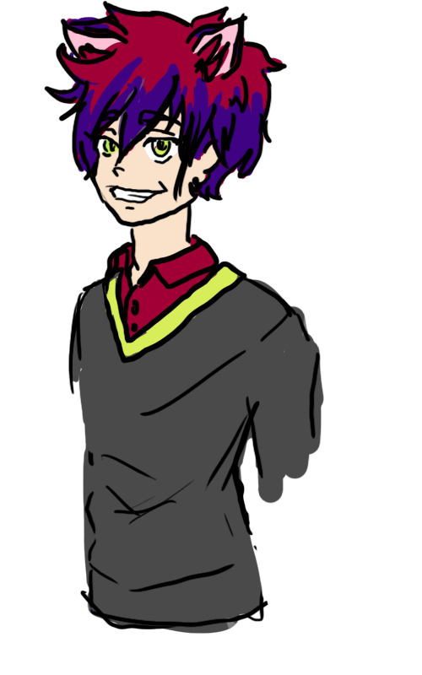

**physical appearance**

A cat with an abnormally large grin. He is always smiling. He has a reddish fur color that is fluffy, earning him the special favor of the Queen. Strangely enough, out of the entire Kingdom of Hearts, he is the only one that sports modern-style clothing. He favors comfortably clothes like hoodies or baggy jeans rather than skin-tight outfits. His favorite color is crimson.

**personality**

He is always smiling, but this smile can look cheery or menacing depending on his mood. The more cheery he looks, the more one should be wary.

**Cinderella (Elizabeth)**

*One of the princesses struggling to find her happily ever after. She is a good friend of Beauty’s, good with household chores, but a bit of an airhead with a naive streak that makes it easy for others to manipulate her. Her fairy godmother has a hard time keeping her guarded. She has currently gone missing after finding out that her stepmother and the king conspired against her.*

**mini-bio**

Born the daughter of a noble and raised to carry herself with poise and grace, her education did not consist of much else until her family’s situaion forced her to become proficient at household chores. Her real name is Elizabeth.

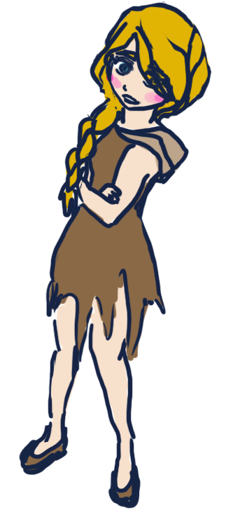

**physical appearance**

Blond and blue-eyed beauty. Really wide eyes, very innocent looking. Rather on the short side, and wears rags covered in soot. She had a nice maid outfit before, but she got tricked by a homeless woman into giving it away.

**personality**

Nice to the point of naivete. She has a strong desire to make everyone around her happy, and as a result never gets to invest time into making herself happy. If someone asks her to do something, she will do it without a second thought. She is not unaware of her unfortunate circumstances and has a tendency to wallow in her miseries, but she can’t really fathom any way to change her unfortunate life because she wouldn’t dream of disobeying her step-family and making them unhappy.

The type that needs someone kind, caring, and strong to take care of her so that she doesn’t get scammed by swindlers or something.

**Special Points**

Has the protection of a fairy godmother who responds to her kind-hearted soul. Currently unreachable because a devil’s mirror shard has corrupted Cinderella’s heart.

**Rachel (“Rattles”)**

*Cinderella’s oldest stepsister. A short woman with a loud voice who thinks with her emotions rather than her head. Currently missing after running away from the prince’s arrest warrants.*

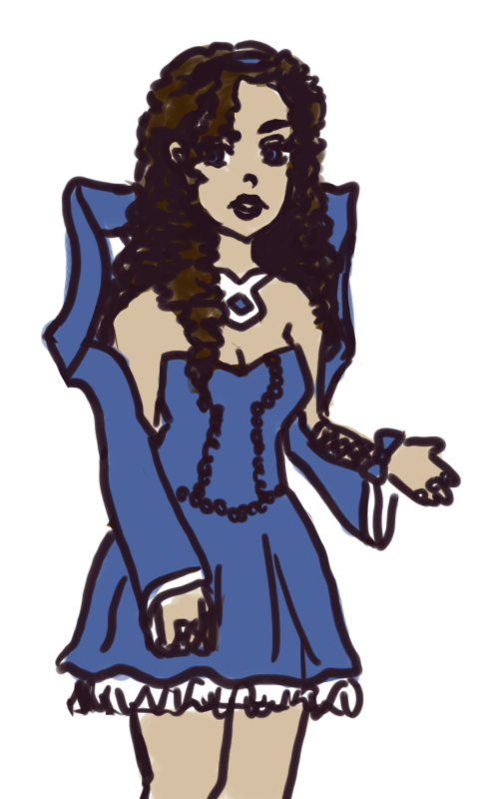

**Appearance**

Shortest out of the three sisters. Also petite - all in all, it makes for a look that causes many people to underestimate her or think of her as the classic, “pretty maiden” type. Because she gets sick and tired of this sort of treatment, she has a tendency to wear a perpetual scowl meant to intimidate other people. She makes up for her lack of height through an abundance in glittering jewels, although as of late, because their family has run into hard times, she has only managed to salvage a couple of her most precious gems. Her clothing resembles the latest styles of their kingdom - mostly Victorian, but with more tolerance for showing bare shoulders, ankles, and arms. In fact, the emerging fashion right now is knee-length skirts (I am seriously making this stuff up as I type). Her hair is curly - she takes great pains to curl them as tight as possible with curlers before going to sleep. She is a brunette.

**Personality**

After her mother remarried into Elizabeth’s family, Rachel took on the role of oldest sister a bit too enthusiastically. She prides herself in her ability to protect and care for her younger charges, but because she can be a little emotional and thick at times, this tends to get them all into a lot of trouble. The first out of the three of them who would throw herself into a street fight. Has a fairly foul mouth, but curbs her tongue when Cinderella is around because that girl is just “too damn innocent.” Ironically, she is also the one out of the 3 to care most about her appearance. She firmly believes that more jewelry means more beauty.

**Clara (“Clover”)**

*Cinderella’s second oldest stepsister. The clever girl of the bunch.*

**Appearance**

Like her sister Rachel, Clara is rather short, though not as short as the oldest sister. She’s a bit chubbier than her other sisters too, because she likes to laze around a lot. She wears longer, ankle-length skirts unlike the knee-lengths that Rachel wears, not because Clara prefers them or anything, but simply because she already owns ankle-lengths from before and does not want to spend new money buying the latest fashion trends. She also wears no jewelry to compensate for the jewelry expenses of her elder sister. Also a brunette - she secretly envies Cinderella’s blond hair, which is considered a classic feature of beauty in their kingdom. She actually wants to have straight hair so always wrestles with her curls, without much success. She ends up with hair that looks bedraggled instead.

**Snow White**

*Princess of the Kingdom of Snow. She has currently gone missing after her kingdom falls into the hands of her husband, the Prince (yet unnamed).*

**Appearance**

She is native to the Kingdom of Snow, where everyone has a rather pale appearance. Has a thick layer of make-up on her face that makes her resemble a kabuki dancer. White skin, red lips, and jet-black hair that has been coated on to the point of exaggeration. She is from the Northern continent, and hence wears winter gear (go creative with this one. Can be modern sweaters or old-fashioned coats, don’t really care). We can actually go with the kabuki dancer theme for her outfit as well if you’re up for it (and make the entire Kingdom of Snow sort of Japanese-themed. That sounds interesting yeah? And we can have other ethnic concepts for the other nations so it’s not all 1600 Europe).

**Personality**

A rather spoiled princess, whose status as the only daughter of the king has gotten her used to getting whatever she wants, even beauty. She is actually not as stunningly beautiful as she likes to believe herself to be. She can be a brat without manners, and thinks everyone has the obligation to cater to her every whim, but she is not truly evil at heart. She is 16 years old, right at the age of puberty, and hence has a rebellious streak a mile wide. Her stepmother the Queen is usually at the receiving end of Snow White’s emotional roller coaster dramas.

**Evil Queen (from Snow White) - Violet**

*A woman of unparalleled beauty who married the ruler of the Kingdom of Snow. She is gifted with witchcraft, and specializes in the creation of potions through a blend of sorcery and alchemy.*

**Appearance**

If one were to be political about it, Queen Snow Violet (last name first) is slightly more beautiful than Snow White - Violet has the beauty of an adult, whilst Snow White is still pretty much a teenager. If Snow White is a kabuki dancer (by looks), then Violet would be a…..geisha? Something like that. She has long, straight, purple hair tied tight against her head - a ponytail or some other sort of hairdo. Generally, she is elegant and impeccable in her court manners. Her scepter doubles as a magic-resistant stirring spoon that she can use to brew potions.

**Personality**

Grew up in a small, poor kingdom on the far East side of the Northern continent. In order to help her kingdom survive, she marries into the royal Snow family of the Kingdom of Snow. She is a woman who knows how to use her beauty to her advantage in the political court. Once she moves into the castle, she tries to make a place for herself within the family, but with Snow White suspicious and resentful, and the castle staff wary of their beautiful but mysterious new mistress, she feels rather lonely at times. She tries to keep her witchcraft practices a secret because unlike her own kingdom, the Kingdom of Snow has a cultural prejudice against all things magical.

**Vivian (Sleeping Beauty)**

*The princess who was cursed and placed into an eternal sleep in a tower closely guarded by Maleficent.*

**Appearance**

She has brown hair and brown eyes, a dark brown that resembles the color of garden soil. Despite her reputation as a sleeping princess, she has a robust build and stands almost six feet tall, easily dwarfing the other princesses in stature. The weather in her kingdom is generally mild, so she tends to go for outfits with short sleeves. She prefers pants or shorts over dresses, but because her parents insist on a princess-like appearance, she has compromised with them by wearing slacks/leggings (some sort of pants type thing) underneath her skirts. This actually makes her look even more weird, but she just doesn’t really care.

**Personality**

A confident, outspoken young woman who fought against her curse for 16 years before finally being overpowered by Maleficent’s spell. She was supposed to have fallen asleep via poke-by-spinning-wheel just a few years after the spell was cast, but she held it off for 16 years through sheer willpower. She hates being pitied over anything else, and has a rather haughty way of speaking to ensure that no one will ever look down on her. She can also be frank in her speech, and has no qualms about insulting people if she feels they deserve it.

**History**